
ECA1803 – OPTOELECTRONICS AND OPTICAL COMMUNICATION CO1 ENGINEERING DESIGN ASSIGNMENT REPORT
PRESENTED BY:
A.M.VISHAL (192412079)
GUIDED BY
Dr.Princy Magdaline Paramanantham

1. Overview and Objectives

1.1 Purpose and summary of results
This report gives the design of an optical fibre link between a central office and a business building. The route length is 60 km, the operating wavelength is 1550 nm, and the link must carry 10 Gb/s traffic now and be upgradable to 100 Gb/s later without laying new fibre. The design follows the usual engineering sequence of eight stages (Section 2). The requirement is first converted into numerical targets, the candidate fibres and techniques are listed, each is analysed by calculation, one is selected with reasons, and finally the complete link is checked against every requirement before a deployment decision is made.
The main results are as follows. Fibre A (V = 1.95) is single-mode, while Fibre B (V = 21.3, about 227 modes) has a modal delay spread of 3.03 µs over 60 km and cannot carry 10 Gb/s. An ITU-T G.652.D trunk with a G.657.A building entry has a passive loss of 13.3 dB and a power margin of 9.7 dB. However, the accumulated chromatic dispersion is 1020 ps/nm, which broadens a pulse to 409 ps against a bit period of 100 ps, so a 10.2 km dispersion-compensating fibre (DCF) is needed. The DCF adds 5.1 dB of loss and reduces the passive margin to 4.6 dB, which is below the required 6 dB. An EDFA pre-amplifier with 14 dB gain is therefore needed. It raises the received power to −2.0 dBm and gives an OSNR of 21.0 dB against the 17 dB requirement. The PMD of the link is 0.775 ps, far below the 10 ps limit at 10 Gb/s. On this basis the link is recommended for deployment, with the conditions given in Section 7.2.

1.2 Design requirement statement
Design Requirement Statement. The 60 km link at 1550 nm shall carry 10 Gb/s NRZ data (bit period 100 ps) with an upgrade path to 100 Gb/s. It shall use ITU-T G.652.D / G.657.A fibre with a buildingentry bend loss of not more than 0.1 dB, shall control chromatic dispersion so that the pulse width does not exceed the bit period, shall keep the mean differential group delay (PMD) within 0.1 of the bit period, and shall provide an OSNR of at least 17 dB (0.1 nm reference bandwidth) with a power margin of at least 6 dB. The transmitter power is +3 dBm and the receiver sensitivity is −20 dBm.

1.3 Objectives
The design has the following measurable objectives, each of which is checked in the final verification (Table 13):
- Carry 10 Gb/s NRZ traffic (bit period 100 ps) over 60 km at 1550 nm, with an upgrade path to 100 Gb/s on the same fibre.
- Use single-mode ITU-T G.652.D / G.657.A fibre, with a building-entry bend loss of not more than 0.1 dB.
- Keep the RMS pulse width after chromatic dispersion at or below the bit period of 100 ps.
- Keep the mean differential group delay (PMD) at or below 0.1 of the bit period (10 ps at 10 Gb/s).
- Provide an OSNR of at least 17 dB (0.1 nm reference bandwidth) and a power margin of at least 6 dB, with P_tx = +3 dBm and receiver sensitivity −20 dBm.
- Reach a justified deploy / do-not-deploy decision supported by calculation.

1.4 Design data and assumptions

Table 1: Design data used in the calculations
Item | Value | Source
Wavelength, bit rate, length | 1550 nm; 10 Gb/s (T_b = 100 ps); 60 km | Given
Fibre A | a = 4.0 µm, n₁ = 1.4500, n₂ = 1.4450 | Given
Fibre B | a = 25.0 µm, n₁ = 1.480, n₂ = 1.465 | Given
Attenuation | Absorption 0.04, Rayleigh 0.11, bending 0.03 dB/km (total  0.18 dB/km) | Given
Discrete losses | 4 connectors × 0.4 dB; 10 splices × 0.08 dB; entry bend 0.8 dB (G.652.D) or 0.1 dB (G.657.A) | Given
Dispersion | D = 17 ps/(nm·km) for G.652.D, 4.5 for G.655, −100 for DCF; source Δλ = 0.4 nm; source pulse 30 ps; DCF loss 0.5 dB/km | Given
PMD | 0.1 ps/√km; birefringence B = 1×10 ⁶⁻ | Given
OSNR | Signal −16.0 dBm, ASE −39.0 dBm; EDFA gain 14 dB, ASE rise 16 dB; required OSNR 17 dB | Given
Transmitter and receiver | P_tx = +3 dBm; sensitivity −20 dBm; margin 6 dB | Given
Assumed by the author | Receiver overload 0 dBm; fibre Bragg grating loss 3 dB;  EDFA noise figure 5.5 dB (cross-check only); B_o = 12.5  GHz and B_e = 7.5 GHz for the Q estimate; group index  1.468; ageing and repair allowance 0.6 dB | Typical values

1.5 Assumptions, missing information and open points
The following items are either assumed by the author or not stated in the assignment data. They are identified here so that no result is mistaken for a given value. None of them changes the final decision, but items 1, 6 and 7 should be confirmed before commissioning.

Table 2: Assumptions, missing information and open points
No. | Item | Status and treatment in this report
1 | Receiver overload power (0 dBm) | Assumed typical value. The EDFA output of −2.0 dBm is only 2 dB below it, so a variable attenuator is included; its setting is not specified and is to be fixed at commissioning.
2 | Receiver type | PIN or APD with transimpedance amplifier; the choice is not given and is left open.
3 | Fibre Bragg grating loss (3 dB) | Assumed; used only in the comparison of compensation alternatives (Table 9).
4 | EDFA noise figure (5.5 dB) | Assumed; used only as a cross-check of the given ASE value. The given ASE (−39.0 dBm) is used in all design calculations.
5 | B_o = 12.5 GHz, B_e = 7.5 GHz; group index 1.468 | Assumed; used only for the Q-factor and BER estimate (idealreceiver upper bound) and for the delay figures.
6 | Ageing and repair allowance (0.6 dB) | Assumed. The EDFA input of −16.0 dBm equals −15.4 dBm less this allowance.
7 | Positions of the four connectors | Not given. They are placed at the central-office ODF, the building ODF, the DCF input and the DCF output (Figure 1). The total of 4 × 0.4 dB is unaffected by the placement.
8 | Attenuation of G.655 fibre | Table 6 gives 0.20 to 0.22 dB/km, but the G.655 alternative in Table 9 uses the same 13.3 dB passive loss as G.652.D (0.18 dB/km). At 0.20 to 0.22 dB/km its margin would be about 7.2 to 5.9 dB instead of 8.35 dB. G.655 is not selected, so the decision is unaffected.
9 | PMD coefficient | The design value of 0.1 ps/√km is used. The G.652.D link design value of 0.2 ps/√km is shown as the worst case (Figure 7). The installed fibre must be measured at acceptance.

2. Complete Sequential Stages

2.1 Stage sequence
The design is carried out in eight stages, from the interpretation of the requirement to the final decision. The output of each stage is the input of the next, as shown in the workflow diagram (Figure 11). Table 3 gives the purpose, inputs, process and outputs of every stage. Table 3: Purpose, inputs, process and outputs of each stage
Stage | Purpose | Inputs | Process | Outputs
1 | Convert the service requirement into numerical targets | Link length, wavelength, bit rate, P_tx, sensitivity, margin, OSNR, standards | Interpret wavelength, light behaviour, standards, loss, dispersion and noise | Numerical targets (Table 4):  17 dB loss allowance, T_b =  100 ps, V < 2.405, PMD ≤  10 ps, OSNR ≥ 17 dB
2 | Select the fibre and propagation configuration | Fibre A and B data;  ITU-T G.652.D, G.655,  G.657.A | Calculate NA, V, number of modes, cut-off, modal delay; compare categories | G.652.D trunk and G.657.A entry (Design Decision 1)
Stage | Purpose | Inputs | Process | Outputs
3 | Develop and evaluate the optical power budget | Attenuation, connectors, splices, bend, P_tx, sensitivity | Compute A_max and the loss of three configurations; test sensitivity | Passive loss 13.3 dB (margin  9.7 dB); with DCF 18.4 dB (margin 4.6 dB), so an EDFA is needed (Design Decision 2)
4 | Control chromatic  dispersion and  PMD | D values, Δλ, source pulse, DCF data, PMD coefficient | Calculate pulse broadening; compare compensation options; size the DCF; calculate PMD | 10.2 km DCF; pulse 30 ps  (50.6 ps at ±10 %); PMD  0.775 ps (Design Decision 3)
5 | Evaluate OSNR  and the amplification strategy | Signal −16.0 dBm, ASE −39.0 dBm, EDFA gain  and ASE rise | Calculate OSNR before and after the EDFA; estimate Q and BER; compare amplifier positions | EDFA pre-amplifier after the DCF; OSNR 21.0 dB, margin 4.0 dB (Design  Decision 4)
6 | Assemble the final link design | Design Decisions 1 to 4 | Combine the selected elements; define the 100 Gb/s upgrade | Link architecture and parameters (Table 11, Figure 12)
7 | Verify the design against every requirement | Stage 6 design and all calculated values | Check each requirement; define acceptance tests | Final verification table  (Table 13); acceptance tests
8 | Assess risks and decide on deployment | Verification results | Identify risks and mitigations; state the conditions | Final deployment decision:  YES, with four conditions

3. Detailed Explanation of Each Stage

3.1 Stage 1: Interpretation of the Communication Requirement
Purpose. To turn each requirement into a physical quantity that can be calculated. Inputs. The Design Requirement Statement and the design data (Table 1). Outputs. The numerical design targets in Table 4.
The design is worked backwards from the service requirement. A 60 km, 10 Gb/s link is a long-reach link, so loss, dispersion and noise all matter at the same time, and the first step is to turn each requirement into a physical quantity that can be calculated.
Wavelength. The wavelength of 1550 nm lies at the minimum of the attenuation curve of silica fibre, where the loss is about 0.18 to 0.2 dB/km. Rayleigh scattering varies as λ ⁴, so the scattering loss at⁻ 1550 nm is smaller than at 1310 nm by a factor of (1550/1310)⁴ ≈ 1.96. The 1550 nm region is also the gain band of the erbium-doped fibre amplifier (EDFA), which is needed in this design. The price paid is that standard fibre has a large chromatic dispersion of about 17 ps/(nm·km) at this wavelength, because the zero-dispersion wavelength of G.652 fibre is near 1310 nm.
Light behaviour. In a large-core fibre, light can be described by rays that are guided by total internal reflection at the core–cladding boundary, and ray theory is sufficient. When the core is only a few wavelengths wide, the guided light must be described as electromagnetic modes obtained by solving Maxwell's equations, and in a weakly guiding fibre these are the linearly polarised LP modes. A highspeed laser transmitter must also have good temporal coherence (a narrow spectral width), because the spectral width multiplies the dispersion in the pulse-broadening calculation, and good spatial coherence so that the beam can be coupled into a small core efficiently.
Standards. Three ITU-T fibre categories are relevant. G.652.D is the standard single-mode fibre with a low water peak, G.655 is the non-zero dispersion-shifted fibre with a reduced dispersion near 1550 nm, and G.657.A is the bend-insensitive fibre intended for building entries and indoor routing, and it can be spliced to G.652.D without difficulty. The requirement of a bend loss of at most 0.1 dB at the building entry points directly to G.657.A for the last section.
Loss, dispersion and noise. The loss budget has to account for the fibre attenuation (absorption, Rayleigh scattering and bending), the connectors and splices, and the bend at the building entry. Chromatic dispersion and polarisation-mode dispersion spread the pulses in time and cause inter-symbol interference when the spread approaches the bit period. Finally, the amplifier adds amplified spontaneous emission (ASE) noise, and the OSNR relative to this noise decides the bit error rate. Table 4 lists the numerical targets that follow from the requirements.

Table 4: Requirements converted to numerical design targets
Requirement | Physical meaning | Numerical target
60 km at 10 Gb/s, +3 dBm, −20 dBm, 6 dB margin | Allowable total loss | 3 − (−20) − 6 = 17 dB
10 Gb/s NRZ | Bit period | T_b = 1/(10×10⁹) = 100 ps
Single-mode operation | Only the fundamental mode guided | V < 2.405
Building-entry bends | Macro-bending loss | ≤ 0.1 dB
Chromatic dispersion | Pulse broadening Δτ = D·Δλ·L | RMS pulse width ≤ T_b = 100 ps
PMD | Mean DGD = coefficient × √L | ≤ 0.1 T_b = 10 ps at 10 Gb/s, 1 ps for 100  Gb/s on-off keying
OSNR | Signal power / ASE power in 0.1  nm | ≥ 17 dB; BER ≤ 10 ¹²⁻
100 Gb/s upgrade | Same fibre, new terminal equipment | No new fibre; check PMD, dispersion and  OSNR again

3.2 Stage 2: Investigation and Selection of the Fibre and Propagation Configuration
Purpose. To choose a fibre that can carry 10 Gb/s over 60 km. Inputs. Fibre A and Fibre B parameters, and the ITU-T categories G.652.D, G.655 and G.657.A. Outputs. The selected trunk and entry fibres (Design Decision 1).

3.2.1 Light acceptance and modal behaviour
The ability of a fibre to accept light is measured by the numerical aperture, and the number of guided modes is decided by the normalised frequency, or V-number. For a step-index fibre these are NA = √(n₁² − n₂²) = sin θ₀, V = 2π a NA / λ, M ≈ V²/2, λc = 2π a NA / 2.405
For Fibre A, NA = √(1.4500² − 1.4450²) = √0.014475 = 0.1203. The acceptance angle in air is θ₀ = sin ¹(0.1203) = 6.9°, the fractional index difference is Δ = (n₁ − n₂)/n₁ = 0.345 %, and the critical angle⁻ at the core–cladding boundary is sin ¹(1.445/1.450) = 85.2°. The V-number at 1550 nm is V = 2π × 4.0⁻ × 0.1203 / 1.55 = 1.951. For Fibre B, NA = √(1.480² − 1.465²) = 0.2102, θ₀ = 12.1°, Δ = 1.01 %, the critical angle is 81.8°, and V = 2π × 25 × 0.2102 / 1.55 = 21.30.

Table 5: Comparison of the two candidate fibres
Quantity | Fibre A | Fibre B
Core radius | 4.0 µm | 25.0 µm
Quantity | Fibre A | Fibre B
Numerical aperture | 0.1203 | 0.2102
Acceptance angle θ₀ | 6.9° | 12.1°
Fractional index difference Δ | 0.345 % | 1.01 %
Critical angle at core–cladding boundary | 85.2° | 81.8°
V-number at 1550 nm | 1.951 | 21.30
Number of modes | 1 (HE₁₁ / LP₀₁), since V < 2.405 | V²/2 ≈ 227
Cut-off wavelength | 1.257 µm (single-mode for λ > 1.26  µm) | Not applicable
Modal dispersion | None | 3.03 µs over 60 km
Theory needed | Wave optics (LP modes) | Ray optics is adequate
Fibre A satisfies the single-mode condition V < 2.405 with a V-number 19 % below the cut-off value, so only the fundamental HE₁₁ mode propagates and modal dispersion is absent (Figure 3). Its cut-off wavelength of 1.257 µm is also consistent with the 1260 nm cable cut-off specified for G.652.D, so the fibre is single-mode in both the 1310 nm and 1550 nm windows. Fibre B supports about 227 modes, and these travel with different group delays.
For a step-index multimode fibre the delay between the axial ray and the ray travelling at the critical angle is

Δτ = (L n₁ / c)(n₁/n₂ − 1) = (60×10³ × 1.48 / 3×10⁸)(1.48/1.465 − 1) = 3.03 µs
The bit rate that can be supported is of the order of 1/(2Δτ) = 0.165 Mb/s, which is smaller than the required 10 Gb/s by a factor of about 60 000. Fibre B is therefore not a possible alternative for this link, whatever its loss may be. The use of ray theory for Fibre B and wave optics for Fibre A is consistent with the core sizes. In Fibre A the core diameter of 8 µm is only about five times the wavelength, and the field has to be treated as a mode with a field distribution that extends into the cladding.

3.2.2 Comparison of ITU-T fibre categories

Table 6: Comparison of the fibre alternatives at 1550 nm
Property | G.652.D | G.655 | G.657.A | Multimode (Fibre B)
Attenuation | ≈ 0.18–0.20 dB/km | ≈ 0.20–0.22 dB/km | ≈ 0.18–0.20 dB/km | Unsuitable for 60 km
Dispersion | ≈ 17 ps/(nm·km) | ≈ 4.5 ps/(nm·km) | ≈ 17 ps/(nm·km) | Modal, 3.03 µs
Pulse width, 60 km, Δλ = 0.4 nm | 408 ps (RSS 409.1 ps) | 108 ps (RSS 112.1 ps) | 408 ps | —
Longest length without compensation | 14.0 km | 53.0 km | 14.0 km | —
Effective area | ≈ 80 µm² | ≈ 55–72 µm² | ≈ 80 µm² | —
Building-entry bend loss | 0.8 dB | ≈ 0.8 dB | 0.1 dB | —
Compatibility | Universal installed base | Needs matched DCF | Splices to G.652.D | —
Property | G.652.D | G.655 | G.657.A | Multimode (Fibre B)
Decision | Trunk fibre | Not selected | Building entry | Rejected
The maximum length without compensation in Table 6 is obtained from the condition that the pulse width must not exceed the bit period, L = √(T_b² − t₀²)/(D·Δλ). For G.652.D this is √(100² − 30²)/(17 × 0.4) = 95.4/6.8 = 14.0 km, and for G.655 it is 95.4/(4.5 × 0.4) = 53.0 km. Even the dispersion-shifted fibre therefore needs compensation at 60 km, although much less than G.652.D. It also has a smaller effective area, which increases the optical intensity for a given power and makes nonlinear effects stronger, and this is a disadvantage for a later coherent 100 Gb/s system.
DESIGN DECISION 1 – FIBRE CONFIGURATION: I recommend ITU-T G.652.D single-mode fibre for the 60 km trunk, with G.657.A fibre at the building entry, because Fibre A is single-mode (V = 1.951 < 2.405, λc = 1.257 µm) and so removes the 3.03 µs modal delay spread that limits Fibre B to about 0.165 Mb/s. G.652.D has a low attenuation of 0.18 dB/km (10.8 dB for 60 km) and a large effective area, which keeps nonlinear effects small for the future 100 Gb/s upgrade. G.657.A reduces the entry bend loss from 0.8 dB to 0.1 dB and can be fusion-spliced to the trunk. G.655 has lower dispersion, but it still needs compensation at 60 km (112 ps against 100 ps), so it does not remove the need for a
DCF.

3.3 Stage 3: Development and Evaluation of the Optical Power Budget
Purpose. To check that enough power reaches the receiver. Inputs. Attenuation, connector, splice and bend losses; P_tx = +3 dBm; sensitivity −20 dBm; required margin 6 dB. Outputs. The loss and margin of each configuration, and the need for an amplifier (Design Decision 2).
The power budget is worked backwards from the receiver. The transmitter launches +3 dBm (1.995 mW) and the receiver needs −20 dBm (10 µW). With a required system margin of 6 dB, the total loss that the link may have is

A_max = P_tx − S_rx − M = 3 − (−20) − 6 = 17 dB
Table 7 gives the loss of each component for the three possible configurations: G.652.D throughout, G.657.A at the entry, and G.657.A at the entry with the DCF module included. The power levels along the link are plotted in Figure 1 and the loss composition in Figure 2.

Table 7: Power budget of the 60 km link
Loss component | G.652.D only | G.657.A entry | G.657.A entry + DCF
Fibre, 0.18 dB/km × 60 km | 10.80 dB | 10.80 dB | 10.80 dB
Connectors, 4 × 0.4 dB | 1.60 dB | 1.60 dB | 1.60 dB
Splices, 10 × 0.08 dB | 0.80 dB | 0.80 dB | 0.80 dB
Building-entry bend | 0.80 dB | 0.10 dB | 0.10 dB
DCF, 10.2 km × 0.5 dB/km | 0 | 0 | 5.10 dB
Total loss | 14.00 dB | 13.30 dB | 18.40 dB
Received power (3 dBm − loss) | −11.00 dBm | −10.30 dBm | −15.40 dBm (28.8 µW)
Margin over −20 dBm | 9.00 dB | 9.70 dB | 4.60 dB
Loss within 17 dB allowance? | Yes | Yes | No (1.4 dB over)
Without the DCF, the link meets the budget comfortably, with 9.7 dB of margin when G.657.A is used. The DCF is however necessary (Stage 4, Section 3.4), and when it is included the total loss becomes 18.4 dB and the received power is −15.4 dBm. The margin is then only 4.6 dB, which is below the required 6 dB, so the passive link with DCF does not meet the requirement. The margin is also sensitive to small changes. If the entry were made with G.652.D rather than G.657.A, the margin would fall to 3.9 dB. For safety, the EDFA analysed in Stage 5 (Section 3.5) is therefore a mandatory part of the design and not an optional improvement.

Table 8: Sensitivity of the margin to design changes (with DCF, without amplifier)
Case | Total loss | P_rx | Margin
Reference: G.657.A + DCF | 18.40 dB | −15.40 dBm | 4.60 dB
G.652.D entry instead of G.657.A | 19.10 dB | −16.10 dBm | 3.90 dB
Repair splice added (0.1 dB) and one extra connector (0.4 dB) | 18.90 dB | −15.90 dBm | 4.10 dB
Ageing/repair allowance of 0.6 dB | 19.00 dB | −16.00 dBm | 4.00 dB
With 14 dB EDFA after DCF (0.6 dB allowance) | 5.00 dB (net) | −2.00 dBm | 18.00 dB
Dominant loss mechanism. Of the 0.18 dB/km fibre attenuation, Rayleigh scattering contributes 0.11 dB/km (6.6 dB over the link), which is 61 % of the total. Absorption contributes 0.04 dB/km (2.4 dB, 22 %) and bending 0.03 dB/km (1.8 dB, 17 %). Rayleigh scattering is intrinsic to the glass, caused by density fluctuations frozen in during fibre drawing.
Nonlinear effects. The launch power of +3 dBm (2 mW) is lower than the stimulated Brillouin scattering threshold of a narrow-linewidth source, which is typically in the range of +6 to +10 dBm, so no nonlinear penalty is expected and a booster amplifier is not needed at the transmitter.
DESIGN DECISION 2 – POWER-BUDGET CONFIGURATION: I recommend a G.652.D trunk with a G.657.A building entry, together with a 14 dB EDFA pre-amplifier in the receive terminal, because G.657.A reduces the bend loss from 0.8 dB to 0.1 dB and raises the margin by 0.7 dB, but even then the link with the DCF has only 4.6 dB of margin against the required 6 dB. The pre-amplifier raises the power at the receiver from −16.0 dBm (including a 0.6 dB ageing allowance) to −2.0 dBm, giving an 18 dB margin over the −20 dBm sensitivity.

3.4 Stage 4: Dispersion Compensation and Polarisation-Mode Dispersion
Purpose. To keep the pulse width within the bit period and the PMD within its limit. Inputs. D = 17, 4.5 and −100 ps/(nm·km); Δλ = 0.4 nm; source pulse 30 ps; DCF loss 0.5 dB/km; PMD coefficient 0.1 ps/√km. Outputs. The DCF length, the compensated pulse width and the PMD (Design Decision 3).

3.4.1 Chromatic dispersion
Chromatic dispersion arises because the group velocity depends on wavelength. In a single-mode fibre it has two parts, material dispersion (the wavelength dependence of the refractive index of silica) and waveguide dispersion (the wavelength dependence of the mode confinement). In G.652.D fibre the two cancel near 1310 nm, but at 1550 nm the net value is about +17 ps/(nm·km). A source with a spectral width Δλ therefore produces a pulse broadening of

Δτ = D · Δλ · L = 17 ps/(nm·km) × 0.4 nm × 60 km = 408 ps
When this is combined with the 30 ps source pulse, the RMS pulse width is √(30² + 408²) = 409.1 ps. This is about four times the 100 ps bit period, so adjacent pulses overlap strongly and inter-symbol interference makes error-free reception impossible. The total dispersion accumulated along the link is D·L = 17 × 60 = 1020 ps/nm. (The 408 ps is the broadening for the 0.4 nm source, whereas the 1020 ps/nm is the accumulated dispersion, and the DCF must cancel the latter.) For G.655 with D = 4.5 ps/(nm·km), the broadening is 108 ps and the RSS width is 112.1 ps, which also exceeds the bit period. The variation of pulse width with length is plotted in Figure 4.

3.4.2 Alternatives for dispersion compensation

Table 9: Comparison of dispersion-compensation alternatives
Option | Added  loss | P_rx and margin (passive) | Residual pulse | Remarks
No compensation (G.652.D) | 0 | −10.3 dBm, 9.7 dB | 409 ps, fails | Simple but unusable because of ISI
DCF, 10.2 km at  −100 ps/(nm·km) | 5.1 dB | −15.4 dBm, 4.6 dB | 30 ps (50.6 ps at  ±10 % error) | Broadband and passive; adds loss, nonlinearity and about 50 µs delay; needs the EDFA
Chirped fibre Bragg grating (3 dB assumed) | 3 dB | −13.3 dBm, 6.7 dB | ≈ 30 ps | Low loss and compact; narrow band, group-delay ripple, wavelength-specific
G.655 fibre with  2.7 km DCF | 1.35 dB | −11.65 dBm, 8.35 dB | 30 ps | Least loss with a DCF; small effective area, not compatible with the G.652.D installed base (see open point 8, Table 2)
Electronic compensation  (coherent receiver) | 0 | −10.3 dBm, 9.7 dB | Corrected in DSP | Best for 100 Gb/s; not available in a 10G NRZ transceiver
The table shows that the fibre Bragg grating and the G.655 option both give a better passive margin than the DCF on G.652.D (Figure 5). The DCF is still preferred for this design for three reasons. First, the EDFA is required anyway to satisfy the OSNR target, so the extra loss of the DCF is absorbed by the amplifier gain. Second, the DCF is broadband and passive, so it does not need tuning to the laser wavelength, whereas the grating compensates only a narrow band and its group-delay ripple can add a penalty. Third, G.652.D is retained for the trunk because of its low nonlinearity and its suitability for coherent transmission, and it is the most widely deployed fibre.
3.4.3 DCF design and tolerance
The length of the DCF follows from the requirement that the net dispersion be zero:

L_DCF = D·L / |D_DCF| = (17 × 60) / 100 = 10.2 km, DCF loss = 10.2 × 0.5 = 5.1 dB
The net dispersion is 1020 − 100 × 10.2 = 0 ps/nm, and the pulse width after compensation is determined only by the 30 ps source pulse, which is 0.3 of the bit period (Figure 6). In practice the DCF value and the fibre dispersion are not exactly known and they vary with temperature and wavelength. For a mismatch of ±10 % the residual dispersion is 102 ps/nm, so the broadening is 0.4 × 102 = 40.8 ps and the pulse width is √(30² + 40.8²) = 50.6 ps, which is half the bit period and still acceptable. This shows that the design has a tolerance and does not depend on perfect compensation. The DCF should be of the slope-matched type so that the residual dispersion remains within this band across the C-band. The signal delay in the DCF is about 10.2 km × 4.9 µs/km = 50 µs, which is small compared with the 294 µs delay of the trunk.

3.4.4 Polarisation-mode dispersion
PMD results from the small, random birefringence of real fibre caused by core ellipticity and stress. The two orthogonal polarisation modes travel with different group velocities, and because the birefringence changes randomly along the fibre, the mean differential group delay grows as the square root of the length:

PMD = 0.1 ps/√km × √60 km = 0.775 ps
At 10 Gb/s the limit is 0.1 T_b = 10 ps, so the link uses 7.7 % of the allowed value and PMD is not a concern (Figure 7). For a 100 Gb/s on-off keyed signal the bit period is 10 ps and the limit is 1 ps. The calculated 0.775 ps satisfies this limit, but only with the design value of 0.1 ps/√km. If the fibre only meets the G.652.D link design value of 0.2 ps/√km, the PMD is 1.55 ps and the limit is exceeded. For this reason, the 100 Gb/s upgrade is planned with coherent dual-polarisation QPSK, which has a symbol rate of about 28 GBd (a symbol period of 35.7 ps) and a digital signal processor that tolerates a differential group delay of many picoseconds. PMD must still be measured at acceptance.
The beat length, which is the distance over which the two polarisation modes accumulate a 2π phase difference, is L_B = λ/B = 1.55 µm / 10 ⁶ = 1.55 m for standard fibre. In polarisation-maintaining fibre⁻ with B ≈ 5×10 ⁴ the beat length is about 3 mm, but its delay accumulates linearly with distance (BL/c ≈⁻ 100 ns over 60 km), so such fibre is not usable for transmission. The random coupling between polarisation modes in ordinary fibre is what makes the PMD grow only as √L.
Because a 100 Gb/s coherent receiver compensates chromatic dispersion electronically, the DCF will not be needed after the upgrade, and an inline DCF would only add loss, noise and nonlinearity. It is therefore removed at the time of the upgrade, which returns 5.1 dB to the power budget.
DESIGN DECISION 3 – DISPERSION AND PMD MANAGEMENT: I recommend G.652.D fibre with a slope-matched 10.2 km DCF module at the receive terminal for the 10 Gb/s service, because the accumulated dispersion of 1020 ps/nm broadens the pulse to 409 ps (more than four bit periods) and the maximum uncompensated length is only 14 km. The DCF restores the pulse to 30 ps (50.6 ps for a ±10 % mismatch). The PMD of 0.775 ps is 7.7 % of the 10 ps limit and meets the 100 Gb/s on-off keying limit of 1 ps for the design coefficient, and coherent detection removes the dependence on PMD for the upgrade. The grating is not chosen because it is narrow-band and wavelength-specific, and G.655 is not chosen because it still needs compensation and has a smaller effective area.

3.5 Stage 5: Evaluation of OSNR and the Amplification Strategy
Purpose. To make sure the received signal is clean enough as well as strong enough. Inputs. Signal
−16.0 dBm and ASE −39.0 dBm at the EDFA input; EDFA gain 14 dB and ASE rise 16 dB; required OSNR 17 dB. Outputs. The OSNR, the BER estimate, the governing constraint and the amplifier position (Design Decision 4).

3.5.1 Role of the EDFA
In an erbium-doped fibre amplifier, a pump laser at 980 nm or 1480 nm excites erbium ions to a higher level, and the signal at 1550 nm causes stimulated emission and is amplified. Some of the excited ions decay spontaneously, and the spontaneous photons are also amplified. This amplified spontaneous emission (ASE) is broadband noise that is added to the signal. The performance measure is the optical signal-to-noise ratio, defined as the signal power divided by the ASE power in a 0.1 nm reference bandwidth (12.5 GHz at 1550 nm). It is used because it can be measured with an optical spectrum analyser and is independent of the receiver electronics. The receive-terminal arrangement is shown in Figure 13.
3.5.2 OSNR calculation
At the amplifier input the signal power is −16.0 dBm and the ASE noise power is −39.0 dBm, so
OSNR_in = −16.0 − (−39.0) = 23.0 dB
The amplifier provides a signal gain of 14 dB and raises the noise by 16 dB:

P_signal,out = −16.0 + 14 = −2.0 dBm, P_ASE,out = −39.0 + 16 = −23.0 dBm, OSNR_out = −2.0 − (−23.0) = 21.0 dB
The noise grows 2 dB more than the signal, because the amplifier adds its own ASE in addition to amplifying the incoming noise. The OSNR therefore falls by 2 dB from 23.0 dB to 21.0 dB (Figure 8). The result of 21.0 dB is above the required 17 dB by 4.0 dB.
3.5.3 BER and the governing constraint
For ASE-limited detection of a 10 Gb/s NRZ signal the Q-factor can be estimated from

Q = 2√(B_o/B_e) · OSNR / (1 + √(1 + 4·OSNR)), BER = ½ erfc(Q/√2)
with B_o = 12.5 GHz and B_e = 7.5 GHz. For OSNR = 21 dB (126) this gives Q = 13.9, and for OSNR = 17 dB it gives Q = 8.5 (BER ≈ 10 ¹⁷). If a 3 dB penalty is allowed for receiver imperfection, crosstalk⁻ and ageing, so that the effective OSNR is 18 dB, then Q = 9.6 and BER ≈ 3×10 ²². These figures are for⁻ an ideal receiver and represent upper bounds, but they show that an OSNR of 17 dB leaves a large BER margin, and the target BER of 10 ¹² is met with a wide safety allowance (Figure 10).⁻
After the EDFA, the received power margin is 18 dB, while the OSNR margin is only 4.0 dB. If the ASE is taken as fixed (the worst case), an additional loss of 4.0 dB ahead of the pre-amplifier would reduce the OSNR to 17 dB (Figure 9). Therefore the OSNR margin, and not the received power margin, is the constraint that limits the link, and the allowance for repairs, ageing and dirty connectors during the life of the link must be kept within 4 dB. As a check on the supplied data, the standard estimate OSNR = 58 + P_in − NF = 58 − 16 − 5.5 = 36.5 dB for a single EDFA with a 5.5 dB noise figure is much higher than 21 dB, so the given ASE value is conservative.

3.5.4 Placement of the amplifier

Table 10: Alternatives for amplifier placement
Option | Effect on power budget | Effect on OSNR | Assessment
No amplifier | Margin 4.6 dB (with DCF), below 6 dB | No ASE, but receiver-noise limited | Does not meet 6 dB margin
Booster at the transmitter | Raises launch power;  nonlinear risk above +6  dBm | Does not improve the receiver-end OSNR | Not needed
In-line amplifier at mid-span | Requires powering and housing in the field | Best OSNR for long spans | Unnecessary for 60 km
Pre-amplifier at the  receiver after the  DCF | Received power −2.0 dBm, 18 dB margin | OSNR 21.0 dB, margin 4.0 dB | Selected
DESIGN DECISION 4 – OSNR AND AMPLIFICATION STRATEGY: I recommend a single
EDFA pre-amplifier (gain 14 dB, ASE rise 16 dB) placed after the DCF in the receive terminal, followed by a variable attenuator and a PIN or APD receiver with a transimpedance amplifier. It brings the received power to −2.0 dBm, which removes the 1.4 dB shortfall in the power margin identified in Stage 3 (Section 3.3), and it gives an OSNR of 21.0 dB, which exceeds the 17 dB requirement by 4.0 dB. A booster is not selected because the +3 dBm launch is already adequate and it would add nonlinear risk without improving the OSNR at the receiver. The 4 dB OSNR margin is the main reserve of the link and is protected by monitoring.

3.6 Stage 6: Link Design
Purpose. To combine the four design decisions into one link. Inputs. Design Decisions 1 to 4. Outputs. The final link architecture (Figure 12) and the design parameters in Table 11.
The final link combines the selections made in the four design decisions. The block diagram in Figure 12 shows the power level at each point, and Table 11 summarises the design parameters.

Table 11: Final link design parameters
Element | Adopted design | Key figures
Transmitter | 1550 nm DFB laser with external modulator, 10 Gb/s NRZ | +3 dBm; Δλ = 0.4 nm; 30 ps pulse
Trunk fibre | ITU-T G.652.D, 60 km | V = 1.951; 0.18 dB/km, 10.8 dB; D = 17 ps/(nm·km); PMD 0.1 ps/√km
Building entry | ITU-T G.657.A | 0.1 dB bend loss
Passive elements | 4 connectors, 10 fusion splices | 1.6 dB and 0.8 dB
Dispersion compensation | Slope-matched DCF, 10.2 km | −1020 ps/nm; loss 5.1 dB; pulse 30 to 50.6 ps
Amplifier | EDFA pre-amplifier with attenuator | −16.0 dBm to −2.0 dBm; OSNR 23.0 dB to 21.0 dB
Receiver | PIN or APD with TIA | Sensitivity −20 dBm; overload ≈ 0 dBm; margin 18 dB
100 Gb/s upgrade | Coherent DP-QPSK transceivers on the same fibre, DCF removed | Passive margin 9.7 dB; symbol period ≈ 35.7 ps; OSNR requirement of coherent receivers is much lower than 21 dB (typically 12 to 15 dB)
The upgrade to 100 Gb/s does not need new fibre. The transmitter and receiver are replaced by coherent dual-polarisation QPSK transceivers, the DCF is taken out (which saves 5.1 dB and also removes a source of nonlinearity), and the digital signal processor corrects the chromatic dispersion of 1020 ps/nm and the PMD. The low PMD of the installed fibre and the large effective area of G.652.D are what allow this upgrade to be made without changing the cable.

3.7 Stage 7: Verification

3.7.1 Verification against the requirements
Purpose. To prove that the complete link meets every requirement. Inputs. The Stage 6 design and the values calculated in Stages 1 to 5. Outputs. The final verification table (Table 13 in Section 6.1) and the acceptance tests below.
The complete link is checked against each requirement in Table 13. Some rows are shown as failing for the individual element, because these failures are the reason that the DCF and the EDFA are included in the design. The corresponding corrected row is given immediately below.

3.7.2 Acceptance tests
- An OTDR test at 1550 nm and 1625 nm to measure the fibre attenuation (0.18 dB/km), each connector (0.4 dB) and each splice (0.08 dB), with a total passive loss not greater than 13.3 dB.
- A power-meter measurement of the transmitter power (+3 dBm) and of the power at the EDFA input (not less than −16 dBm).
- A chromatic-dispersion measurement to confirm 1020 ps/nm ± 10 % for the trunk and a residual of not more than ±102 ps/nm after the DCF.
- A PMD measurement to confirm a mean DGD below 1 ps before the 100 Gb/s upgrade.
- An optical spectrum analyser measurement of the OSNR (not less than 17 dB in 0.1 nm), with an alarm when the margin falls below 2 dB.

3.8 Stage 8: Risk Assessment and Final Decision
Purpose. To identify what could erode the margins and to state the deployment decision. Inputs. The verification results. Outputs. The risk table and the final decision (Section 7.2).

Table 12: Risks and mitigation
Risk | Effect | Mitigation
Added loss from repairs, ageing or dirty connectors | Reduces OSNR; only 4.0 dB reserve | Fusion-spliced repairs, connector inspection, OSNR monitoring and alarm
DCF mismatch with temperature or wavelength | Residual dispersion; pulse up to  50.6 ps at ±10 % | Slope-matched DCF; measure dispersion at acceptance
Receiver overload at −2.0 dBm | Errors or damage to the receiver | Variable attenuator; EDFA in constantoutput mode
PMD above 0.1 ps/√km in older fibre | Limits 100 Gb/s on-off keying | Measure PMD; use coherent 100 Gb/s transceivers
DCF kept after the upgrade | Extra loss and nonlinearity | Remove the DCF at the upgrade

4. Relevant Graphs and Charts
All graphs are drawn from the values calculated in Section 3; no other data are used. Every graph is followed by a short explanation of what it shows, how to read it and why it matters.
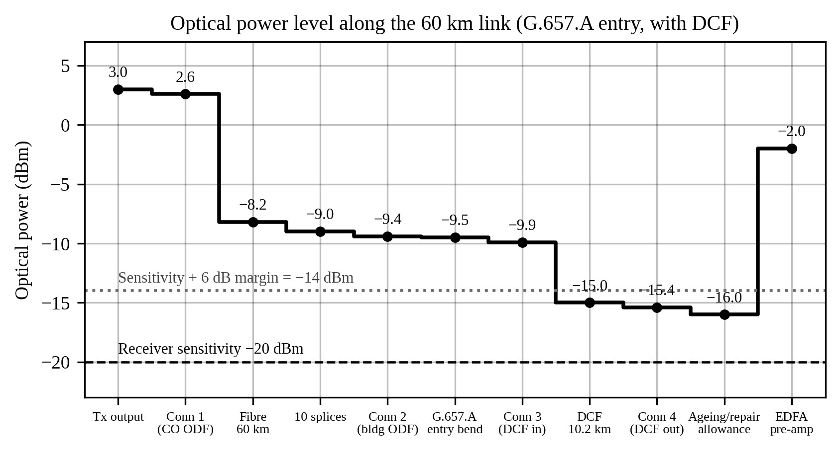
Figure 1: Optical power level along the 60 km link (G.657.A entry, with DCF)
What it shows. The optical power after each element, starting at +3.0 dBm at the transmitter and ending at −2.0 dBm after the EDFA. The element losses are those of Table 7, with the 0.6 dB ageing and repair allowance added before the amplifier.
How to read it. Each step down is a loss. The fibre (10.8 dB) and the DCF (5.1 dB) are the two large drops. The dotted line is the sensitivity plus the 6 dB margin (−14 dBm) and the dashed line is the receiver sensitivity (−20 dBm); the signal falls below the dotted line after the DCF and is restored by the EDFA.
Why it matters. It shows that the passive link with the DCF misses the 6 dB margin and why the EDFA is mandatory.
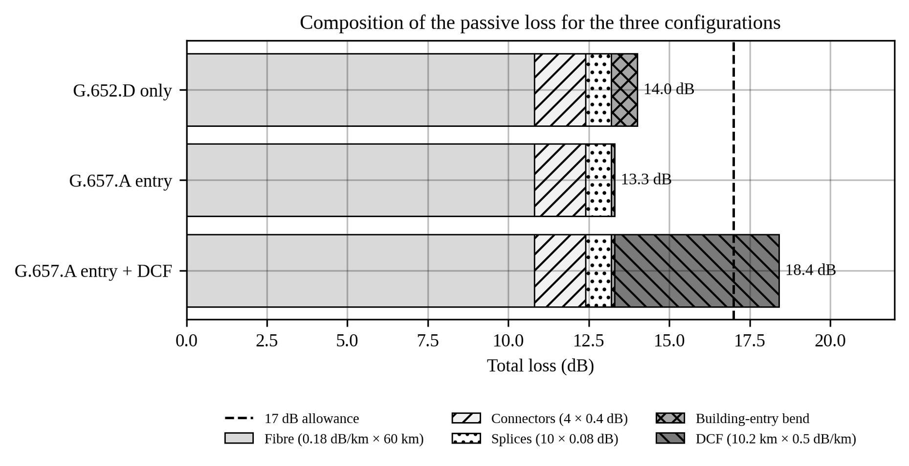
Figure 2: Composition of the passive loss for the three configurations
What it shows. The stacked contribution of fibre, connectors, splices, entry bend and DCF to the total loss of Table 7.

Each bar ends at the total loss (14.0, 13.3 and 18.4 dB); the dashed line is the 17 dB
allowance. Only the bar with the DCF crosses it.
Why it matters. It shows that the fibre dominates the passive loss (10.8 of 13.3 dB), that G.657.A saves 0.7 dB, and that the DCF alone causes the 1.4 dB excess.
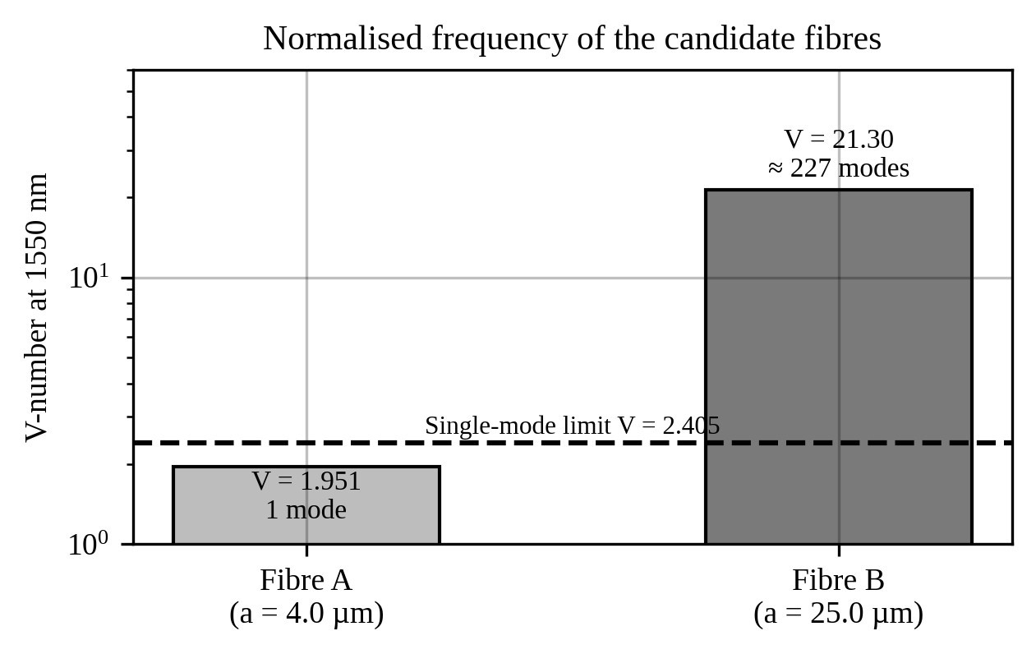
Figure 3: Normalised frequency of the candidate fibres
What it shows. The V-number of Fibre A (1.951) and Fibre B (21.30) on a logarithmic axis, with the singlemode limit V = 2.405.
How to read it. A bar below the dashed line means a single guided mode. Fibre B is almost ten times above the limit and supports about 227 modes.
Why it matters. It is the basis of Design Decision 1: only Fibre A avoids the 3.03 µs modal delay spread.
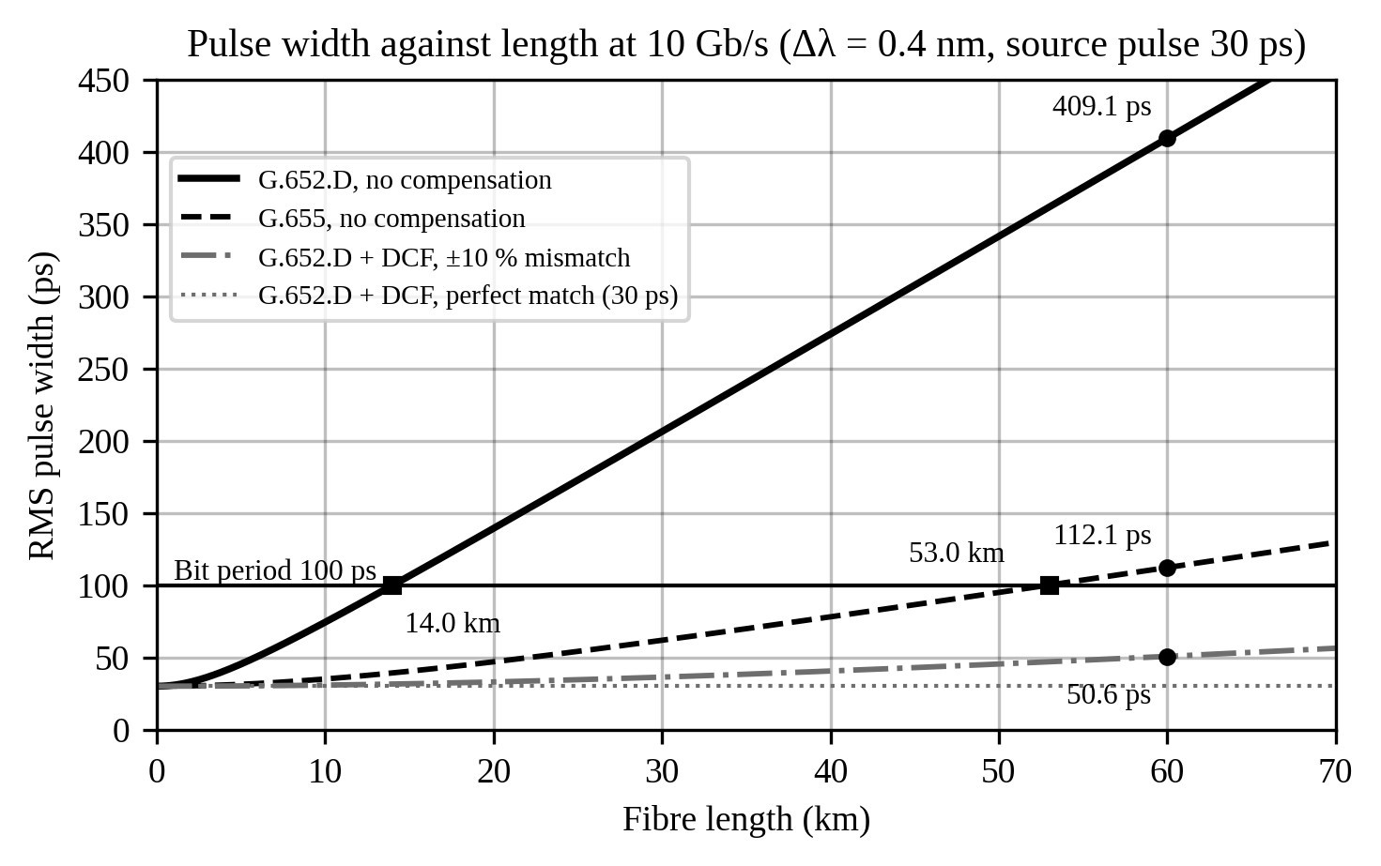
Figure 4: Pulse width against fibre length at 10 Gb/s (Δλ = 0.4 nm, source pulse 30 ps)
What it shows. The RMS pulse width calculated as √(t₀² + (D·Δλ·L)²) for G.652.D and G.655 without compensation, and for G.652.D with the DCF (perfect match and ±10 % mismatch).
The horizontal line is the 100 ps bit period. The curves cross it at 14.0 km (G.652.D) and 53.0
km (G.655). At 60 km the widths are 409.1 ps, 112.1 ps and 50.6 ps (with ±10 % mismatch).
Why it matters. It shows that both uncompensated fibres fail at 60 km and that the DCF brings the pulse back well inside the bit period.
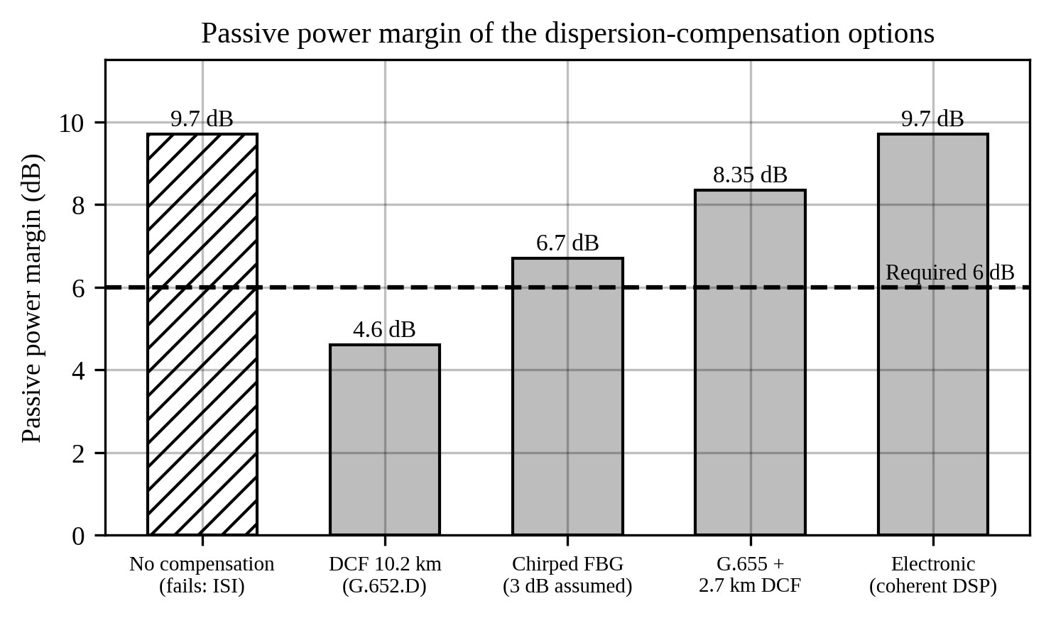
Figure 5: Passive power margin of the dispersion-compensation options
What it shows. The passive power margin (without the EDFA) of the five options in Table 9.
How to read it. The dashed line is the required 6 dB. The hatched bar (no compensation) has a high margin but fails on dispersion. The 3 dB grating loss is an assumed value, and the G.655 bar uses 0.18 dB/km (open point 8).
Why it matters. It shows that the chosen DCF has the lowest passive margin (4.6 dB), which is accepted because the EDFA is required anyway.
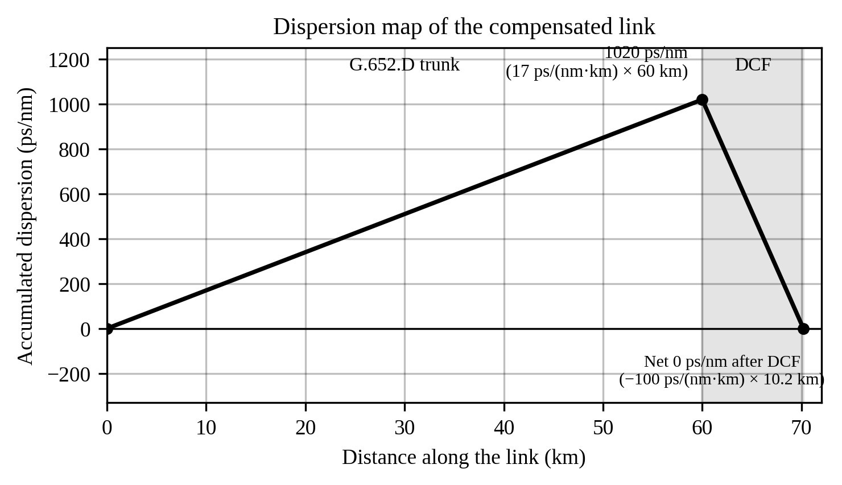
Figure 6: Dispersion map of the compensated link What it shows. The accumulated dispersion along the trunk and the DCF.
The dispersion rises at 17 ps/(nm·km) to 1020 ps/nm over 60 km, then falls at 100
ps/(nm·km) over the 10.2 km DCF to zero.
Why it matters. It confirms the DCF length of 10.2 km: the net dispersion at the receiver is 0 ps/nm.
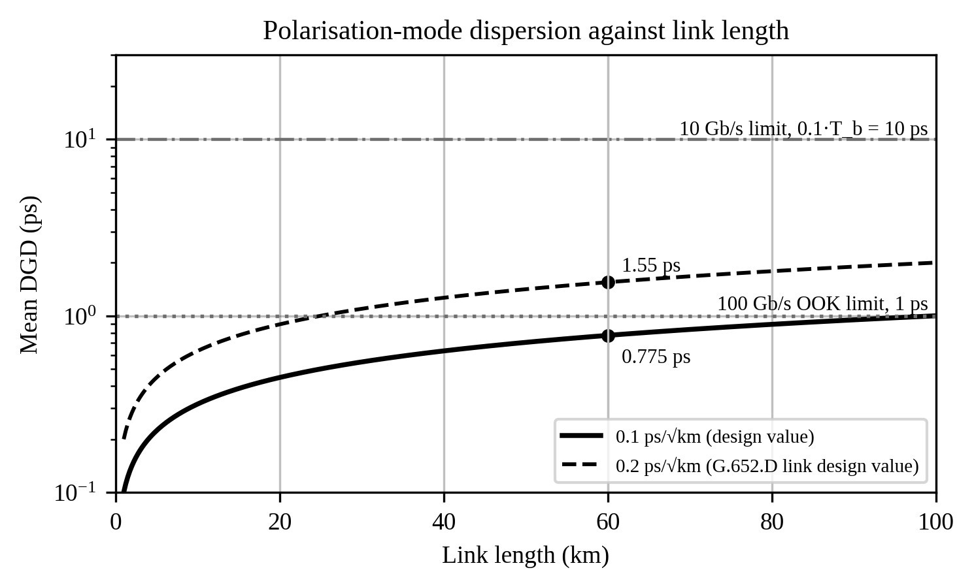
Figure 7: Mean DGD against link length with the limits for 10 Gb/s and 100 Gb/s on-off keying
What it shows. Mean differential group delay = coefficient × √L for 0.1 and 0.2 ps/√km, on a logarithmic axis, with the 10 ps and 1 ps limits.
How to read it. At 60 km the design coefficient gives 0.775 ps and 0.2 ps/√km gives 1.55 ps. Only the higher value crosses the 1 ps line.
Why it matters. PMD is not a concern at 10 Gb/s, and it explains why the 100 Gb/s upgrade uses coherent detection and why PMD must be measured at acceptance.
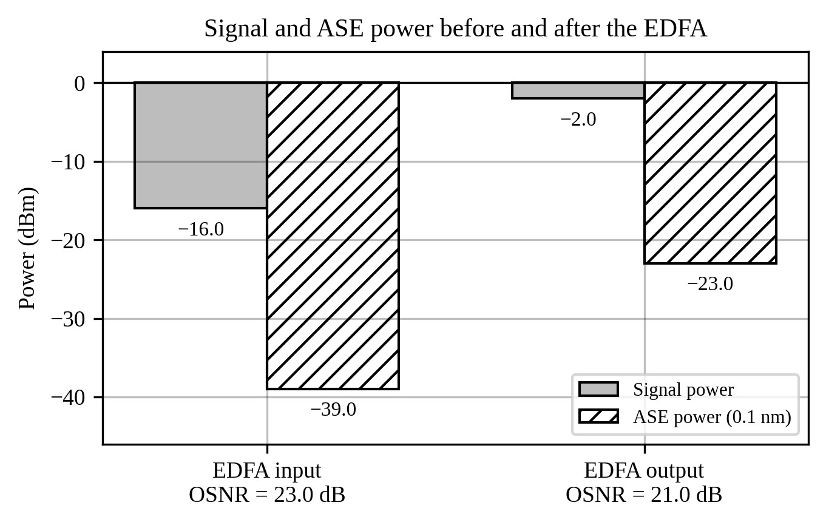
Figure 8: Signal and ASE power before and after the EDFA
What it shows. The signal and ASE powers at the EDFA input (−16.0 and −39.0 dBm) and output (−2.0 and −23.0 dBm).
The signal rises by 14 dB and the ASE by 16 dB, so the gap between them, the OSNR, falls
from 23.0 dB to 21.0 dB.
Why it matters. It shows the cost of amplification in OSNR and the 4.0 dB margin over the 17 dB requirement.
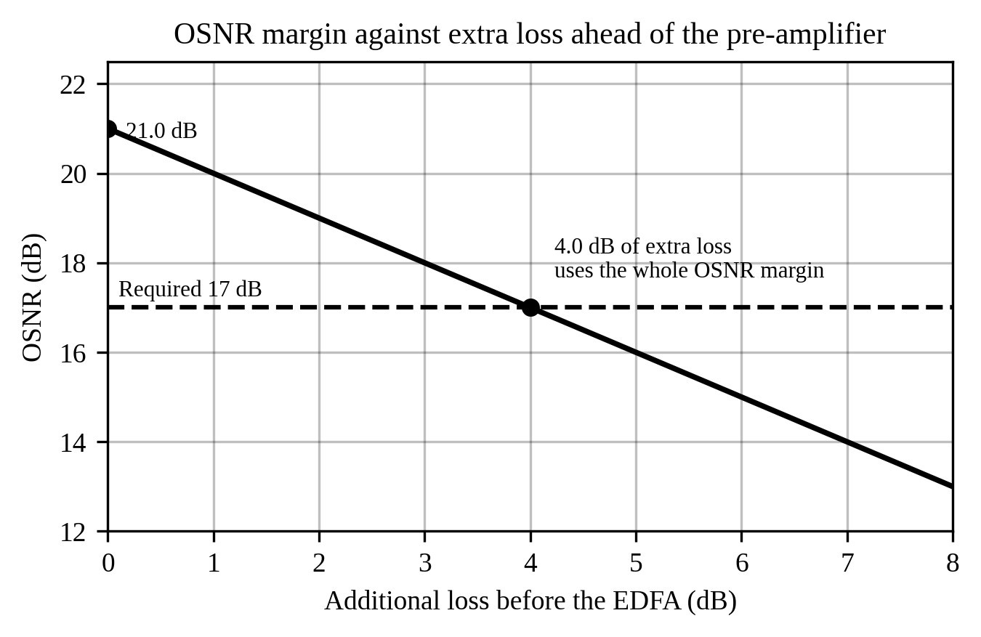
Figure 9: OSNR margin against extra loss ahead of the pre-amplifier
What it shows. The OSNR at the EDFA output as extra loss is added before the amplifier, with the ASE taken as fixed (the worst case used in Section 3.5.3).
How to read it. The line falls by 1 dB for each dB of extra loss and meets the 17 dB requirement at 4.0 dB.
Why it matters. It shows that the OSNR margin is the governing constraint and sets the limit on the repair and ageing allowance.
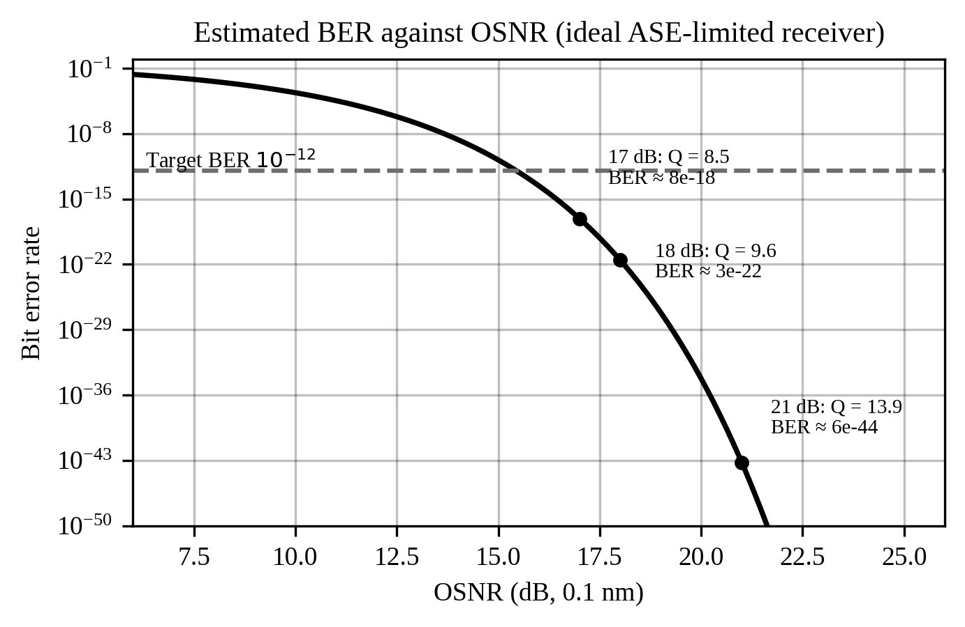
Figure 10: Estimated BER against OSNR for an ideal ASE-limited receiver
What it shows. BER = ½ erfc(Q/√2) with the Q-factor formula of Section 3.5.3 (B_o = 12.5 GHz, B_e = 7.5 GHz), with the points for 17, 18 and 21 dB.
The BER falls steeply with OSNR. The target is 10 ¹². The values are upper bounds for an⁻
ideal receiver, not predictions for real hardware.
Why it matters. It shows that an OSNR of 17 dB already leaves a large BER margin, so the OSNR requirement, not the BER target, is the practical limit.

5. Block Diagrams
Three block diagrams show the design process, the complete link and the receive terminal. Arrows show the direction of the flow of the signal or of the design information.
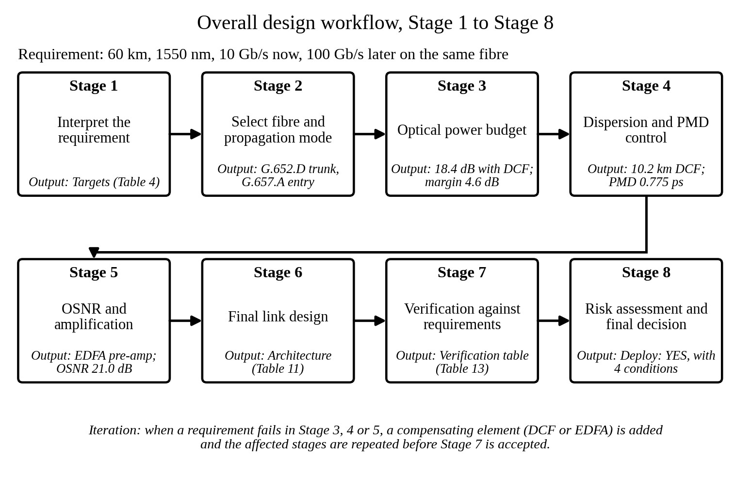
Figure 11: Overall design workflow, Stage 1 to Stage 8
What it represents. The eight stages of Section 2 in order, with the main output of each stage.
How to interpret it. Follow the arrows from Stage 1 to Stage 4 on the first row and from Stage 5 to Stage 8
on the second row. The note below the diagram says that a failed requirement leads to a compensating element (DCF or EDFA) and a repeat of the affected stages.
Why it is relevant. It shows that each stage uses the result of the previous one and that the verification in Stage 7 closes the design.

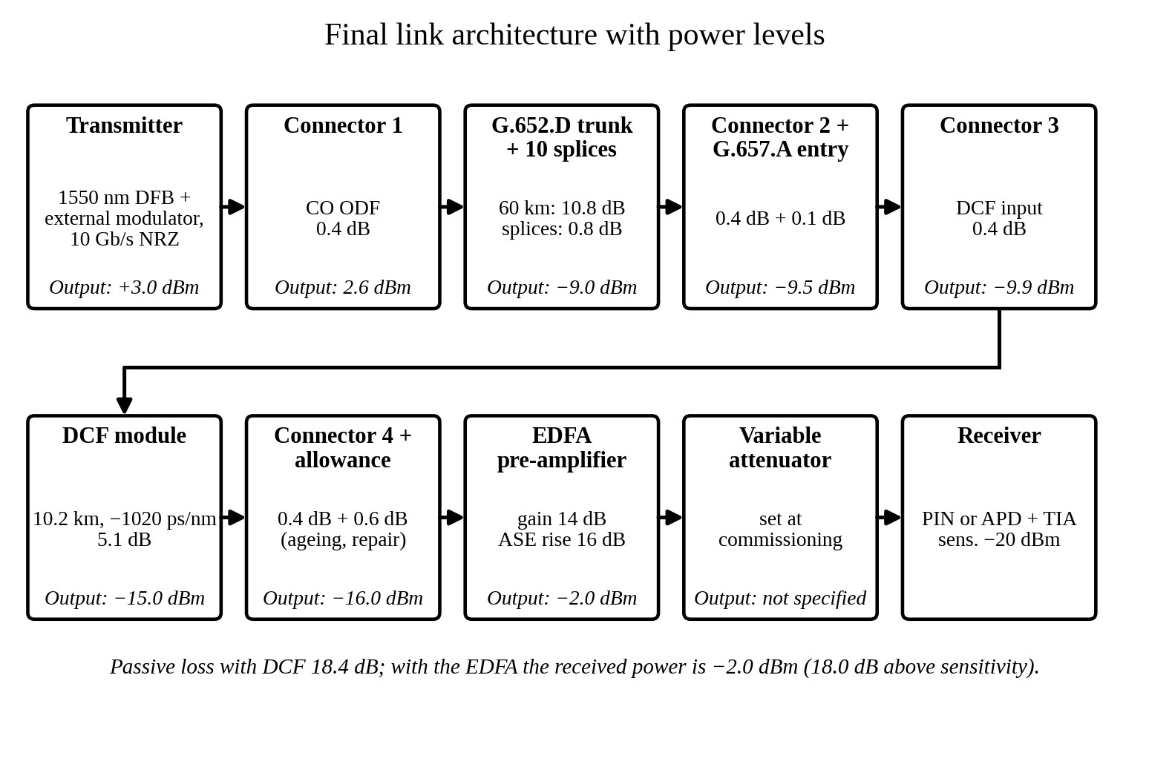
Figure 12: Final link architecture with power levels
What it represents. The complete link from the transmitter to the receiver, with the loss of each element and the power after it (the values of Figure 1).
How to interpret it. The first row runs from the central office to the DCF input; the connector joins to the second row, which runs through the DCF, the EDFA and the attenuator to the receiver. The attenuator setting is not specified (open point 1).
Why it is relevant. It is the single picture of the adopted design and ties together Design Decisions 1 to 4.
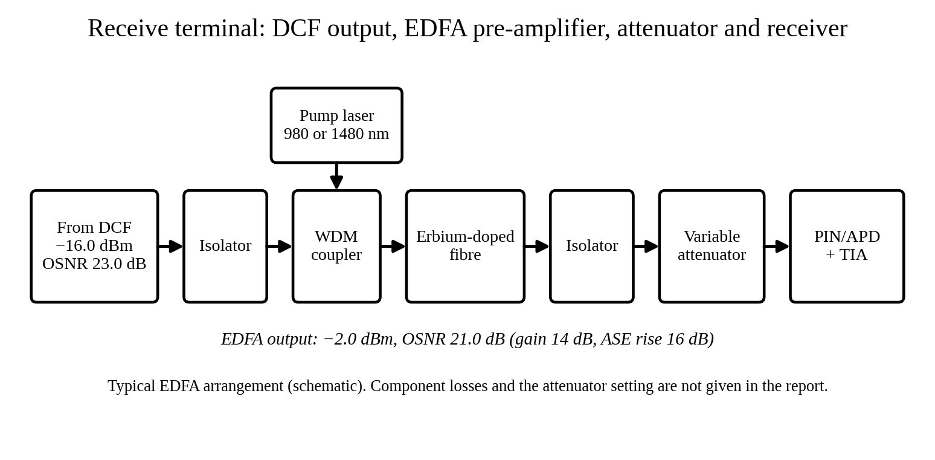
Figure 13: Receive terminal: DCF output, EDFA pre-amplifier, attenuator and receiver
What it represents. The receive terminal in more detail: the signal from the DCF passes through an isolator and a WDM coupler that adds the pump light, then through the erbium-doped fibre, a second isolator, the variable attenuator and the receiver.
How to interpret it. The pump enters from above. The input is −16.0 dBm with an OSNR of 23.0 dB; the output is −2.0 dBm with an OSNR of 21.0 dB. The internal arrangement is a typical EDFA schematic and its component losses are not part of the given data.
Why it is relevant. It shows where the gain, the ASE and the overload protection arise in the receive terminal.

6. Results, Analysis and Key Observations

6.1 Final verification table
The complete link is checked against each requirement in Table 13.

Table 13: Final verification table
Requirement | Specified / Target | Achieved | Margin | Satisfactory?
Modal condition | Single-mode, V <  2.405 | V = 1.951; λc = 1.257 µm | 19 % below cut-off | Yes
Fibre category | G.652.D trunk,  G.657.A entry | G.652.D and G.657.A | — | Yes
Fibre attenuation | 0.18 dB/km | 0.18 dB/km, 10.80 dB | 0 | Yes
Building-entry bend loss | ≤ 0.1 dB | 0.10 dB | 0 | Yes
Passive loss without  DCF | ≤ 17 dB | 13.30 dB | 3.7 dB | Yes
Passive loss with  DCF | ≤ 17 dB | 18.40 dB | −1.4 dB | No – EDFA needed
Requirement | Specified / Target | Achieved | Margin | Satisfactory?
Power margin,  passive link with  DCF | ≥ 6 dB (P_rx −15.4 dBm) | 4.60 dB | −1.4 dB | No – corrected in next row
Power margin with  EDFA | ≥ 6 dB, below overload | P_rx −2.0 dBm; 18.0 dB | +12.0 dB | Yes
Pulse width without compensation | ≤ 100 ps | 409.1 ps (limit 14.0 km) | −309 ps | No – DCF needed
Pulse width with  DCF | ≤ 100 ps | 30 ps; 50.6 ps at ±10 % | ≥ 49 ps | Yes
DCF design | Cancel 1020 ps/nm | 10.2 km; loss 5.1 dB | 0 ps/nm residual | Yes
PMD at 10 Gb/s | ≤ 10 ps | 0.775 ps (1.55 ps worst case) | 9.2 ps | Yes
PMD at 100 Gb/s | ≤ 1 ps (OOK) or coherent DSP | 0.775 ps (design) | 0.23 ps | Conditional – use coherent, measure PMD
OSNR | ≥ 17 dB | 23.0 dB in, 21.0 dB out | 4.0 dB | Yes
BER | ≤ 10 ¹²⁻ | Q = 13.9 (Q = 9.6 with 3 dB penalty) | Many decades | Yes
Nonlinear effects | No penalty | +3 dBm below SBS threshold | ≥ 3 dB | Yes
100 Gb/s upgrade path | Same fibre | Coherent DP-QPSK, DCF removed | Margin 9.7 dB | Yes
Overall link | All requirements | Met with the EDFA; 4 dB  OSNR margin is smallest | 4.0 dB | Yes
The table shows that the three failures (passive loss with DCF, passive margin with DCF, and pulse width without compensation) belong to elements of the design that are corrected by the DCF and the EDFA. With the two components included, every requirement is met, and the smallest margin is the 4.0 dB OSNR margin. The earlier statement that a margin of 4.6 dB satisfies a requirement of 6 dB would not be correct, and the 18.0 dB margin after amplification is the correct figure for the final link.

6.2 Key results

Table 14: Summary of the principal calculated results
Quantity | Value | Requirement / limit
V-number, Fibre A / Fibre B | 1.951 / 21.30 (1 mode / ≈ 227 modes) | V < 2.405
Modal delay spread of Fibre B, 60 km | 3.03 µs (about 0.165 Mb/s) | Bit period 100 ps
Passive loss: G.652.D / G.657.A / G.657.A + DCF | 14.0 / 13.3 / 18.4 dB | ≤ 17 dB
Power margin: passive / with DCF / with EDFA | 9.7 / 4.6 / 18.0 dB | ≥ 6 dB
Accumulated dispersion; pulse width before / after DCF | 1020 ps/nm; 409.1 ps / 30 ps | ≤ 100 ps
Quantity | Value | Requirement / limit
DCF length and loss | 10.2 km; 5.1 dB | —
Mean DGD at 60 km | 0.775 ps (1.55 ps worst case) | ≤ 10 ps at 10 Gb/s
OSNR before / after the EDFA | 23.0 / 21.0 dB | ≥ 17 dB
Q-factor at 21 / 17 / 18 dB OSNR | 13.9 / 8.5 / 9.6 | BER ≤ 10 ¹²⁻

6.3 Analysis and key observations
- The governing constraint changes from power to noise. The passive link has a comfortable 9.7 dB power margin, but after the DCF and the EDFA the power margin is 18.0 dB while the OSNR margin is only 4.0 dB. The life-time allowance for repairs, ageing and dirty connectors must stay within 4 dB (Figure 9).
- Chromatic dispersion is the largest impairment. The uncompensated pulse is 409.1 ps, about four times the bit period, and the longest uncompensated G.652.D length is only 14.0 km (Figure 4).
- Compensation has a price. The DCF adds 5.1 dB and lowers the passive margin from 9.7 dB to
4.6 dB. Removing it at the 100 Gb/s upgrade returns the 5.1 dB.
- The fibre dominates the passive loss. The fibre is 10.8 dB of the 13.3 dB passive loss, and Rayleigh scattering is 61 % of the fibre attenuation. G.657.A at the entry saves 0.7 dB compared with G.652.D, and a 0.6 dB ageing allowance takes a further 0.6 dB from the margin (Table 8).
- PMD is not limiting at 10 Gb/s (7.7 % of the 10 ps limit), but at 100 Gb/s on-off keying the margin is only 0.23 ps, and a coefficient of 0.2 ps/√km would exceed the limit. Coherent detection and an acceptance measurement remove this risk.
- Receiver overload margin is small. The EDFA output of −2.0 dBm is 2 dB below the assumed 0 dBm overload. The variable attenuator in the design protects the receiver, and its setting should be fixed at commissioning.
- BER is not the practical limit. Even at 17 dB the estimated BER is far below 10 ¹² (an upper⁻ bound for an ideal receiver), so the OSNR requirement is the practical limit.

6.4 Validation of this report
The stage order, the calculations, the graph labels, the diagram connections and the completeness of the content were checked. Every calculated value was recalculated independently. All agree with the original report except the item corrected in the first row below.

Table 15: Validation checks and corrections
Check | Result
Correction: Table 9, G.655 option | The received power was given as −14.65 dBm. With a total loss of 14.65 dB it is 3 − 14.65 = −11.65 dBm. The margin of 8.35 dB was already correct. The table is corrected.
Stage order and numbering | The original used mixed numbering (Stage 1 to 5 and Sections 1 to 10, offset by one). It now has eight stages, numbered consistently, and all cross-references are updated.
Fibre calculations | NA, θ₀, Δ, critical angle, V, number of modes, cut-off wavelength, modal delay of 3.03 µs and the 0.165 Mb/s bit rate all recalculated and confirmed.
Check | Result
Power budget | Totals 14.00, 13.30 and 18.40 dB, powers −11.0, −10.3 and −15.4 dBm (28.8 µW), margins 9.0, 9.7 and 4.6 dB, the four sensitivity cases of Table 8, and the Rayleigh, absorption and bending shares (61, 22, 17 %) confirmed.
Dispersion and PMD | 408 ps, 409.1 ps, 108 ps, 112.1 ps, 14.0 km, 53.0 km, 10.2 km, 5.1 dB, 40.8 ps, 50.6 ps, 294 µs and 50 µs delays, 0.775 ps, 1.55 ps, beat lengths of 1.55 m and 3 mm and 100 ns confirmed.
OSNR and BER | 23.0 and 21.0 dB, the 4.0 dB margin, Q = 13.9, 8.5 and 9.6, BER ≈ 10 ¹⁷ at 17 ⁻ dB and ≈ 3×10 ²² at 18 dB, and the 36.5 dB cross-check confirmed.⁻
Graphs and diagrams | All ten graphs and three block diagrams were redrawn in one plain black-andwhite style from the values in the report; labels, units, legends and arrows were checked. The power levels of Figure 1 reproduce the original power-level diagram.
Open points | Assumed or missing items are listed in Table 2. None changes the decision.

7. Final Summary and Conclusions

7.1 Summary
The 60 km, 1550 nm link was designed in eight stages. The fibre is single-mode (V = 1.951 < 2.405), so modal dispersion is absent, whereas the multimode alternative would be limited to 0.165 Mb/s by a delay spread of 3.03 µs. The passive loss of 13.3 dB gives a margin of 9.7 dB, but once the necessary 5.1 dB DCF is added the margin is 4.6 dB, below the 6 dB requirement, and so the EDFA is made a
mandatory part of the design. With the amplifier, the received power is −2.0 dBm and the margin is 18 dB. Chromatic dispersion of 1020 ps/nm is cancelled by a 10.2 km DCF, which reduces the pulse width from 409 ps to 30 ps (50.6 ps for a ±10 % mismatch). The PMD of 0.775 ps is much smaller than the 10 ps limit at 10 Gb/s, and the upgrade to 100 Gb/s with coherent detection does not depend on it. The OSNR of 21.0 dB exceeds the 17 dB requirement by 4.0 dB, and the estimated BER is far below 10 ¹².⁻

7.2 Final engineering decision and deployment recommendation
FINAL DEPLOYMENT DECISION: YES. The link is approved for deployment, subject to the conditions given below. The conditions of approval are:
- The EDFA pre-amplifier and the receiver attenuator are installed, because the passive link with the DCF does not meet the 6 dB margin.
- The OSNR margin of 4 dB is monitored, with an alarm when more than 2 dB has been used.
- All acceptance tests of Section 3.7.2 are passed before the service is commissioned.
- The DCF is removed when the 100 Gb/s coherent transceivers are installed.
If these conditions are met, the link will provide reliable 10 Gb/s service and can be upgraded to 100 Gb/s on the same fibre.

7.3 Conclusions
- Single-mode G.652.D fibre with a G.657.A entry is the correct fibre choice; the multimode fibre is rejected on modal dispersion.
- Dispersion compensation (10.2 km DCF) and amplification (14 dB EDFA pre-amplifier) are both required; neither can be omitted.
- The OSNR margin of 4.0 dB is the smallest margin in the design and is the quantity to monitor in service.
- The 100 Gb/s upgrade needs no new fibre, provided coherent transceivers are used, the DCF is removed and the PMD is confirmed at acceptance.
- The assumed values and open points in Table 2 should be confirmed at commissioning.

References
- ITU-T Recommendation G.652, Characteristics of a single-mode optical fibre and cable, 2016.
- ITU-T Recommendation G.655, Characteristics of a non-zero dispersion-shifted single-mode optical fibre and cable, 2009.
- ITU-T Recommendation G.657, Characteristics of a bending-loss insensitive single-mode optical fibre and cable, 2016.
- G. Keiser, Optical Fiber Communications, 5th ed., McGraw-Hill, 2021.
- G. P. Agrawal, Fiber-Optic Communication Systems, 4th ed., Wiley, 2010.
- P. C. Becker, N. A. Olsson and J. R. Simpson, Erbium-Doped Fiber Amplifiers: Fundamentals and Technology, Academic Press, 1999.
- B. E. A. Saleh and M. C. Teich, Fundamentals of Photonics, 3rd ed., Wiley, 2019.

